|  |  |  |  |  |  |  |
| --- | --- | --- | --- | --- | --- | --- |
| DISTRIBUTION : | Firm | To | Ref | Copies | 1st page | e-mail |
|  |  |  |  |  |  |  |
|  |  |  |  |  |  |  |
|  |  |  |  |  |  |  |
|  |  |  |  |  |  |  |
|  |  |  |  |  |  |  |

**How OpenProject Estimated Effort works**

OBJECT

This document describes how to use OpenProject_Estimated_Effort script.

SUMMARY

/

CONCLUSION

/

|  |  |  |
| --- | --- | --- |
| STATUS: | For comments | ✓ |
|  | For application |  |

|  |  |  |
| --- | --- | --- |
| Established by | Reviewed by | Approved by |
| Name: Gustescu Mihai Emilian  Date: 23.03.2023  Visa: | Name:  Date:  Visa: | Name:  Date:  Visa: |

The present document contains **4 pages**.

# EVOLUTION OF THE DOCUMENT

|  |  |  |  |  |
| --- | --- | --- | --- | --- |
| **Issue** | **Date** | **Author** | **Rev.** | **Motive and nature of the modifications** |
| ?????? | 23.03.2023 | Gustescu Mihai Emilian | 1.1 | First Edition |
|  |  |  |  |  |
|  |  |  |  |  |
|  |  |  |  |  |
|  |  |  |  |  |
|  |  |  |  |  |

**CONTENTS**

EVOLUTION OF THE DOCUMENT 2

1. RELEVANT DOCUMENTS 4

2. GLOSSARY OF TERMS / EXPRESSIONS 4

3. HOW THE SCRIPT WORKS 4

# RELEVANT DOCUMENTS

|  |  |  |
| --- | --- | --- |
| **N°** | **Title** | **Reference** |
|  |  |  |

# GLOSSARY OF TERMS / EXPRESSIONS

|  |  |
| --- | --- |
| ***Term*** | ***Definition*** |
| ***BAT*** | *Batch File ( Windows batch file extension )* |
|  |  |
|  |  |

# HOW THE SCRIPT WORKS

This script has two arguments to be called:

-i: The input file with all information

-o: The output Excel file containing all the data

Check the names in the .bat files so they would match the names of the files you want to work with.

It is recommend first to create a new page with all work packages in OpenProject, to have access to closed issues as well.

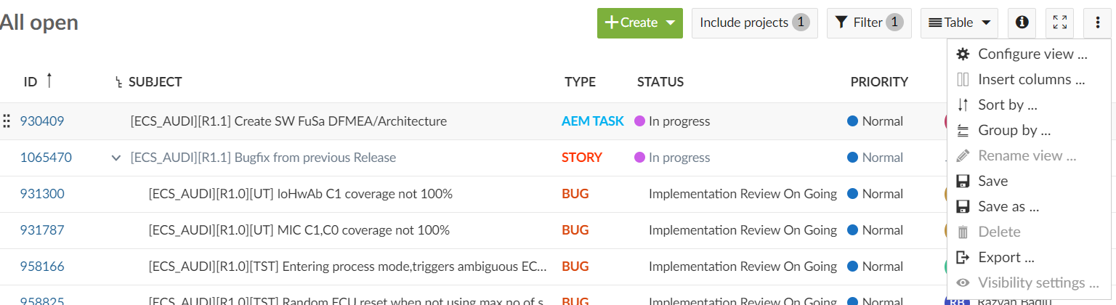

First filter the list so you can see all issues. Then click on save as.

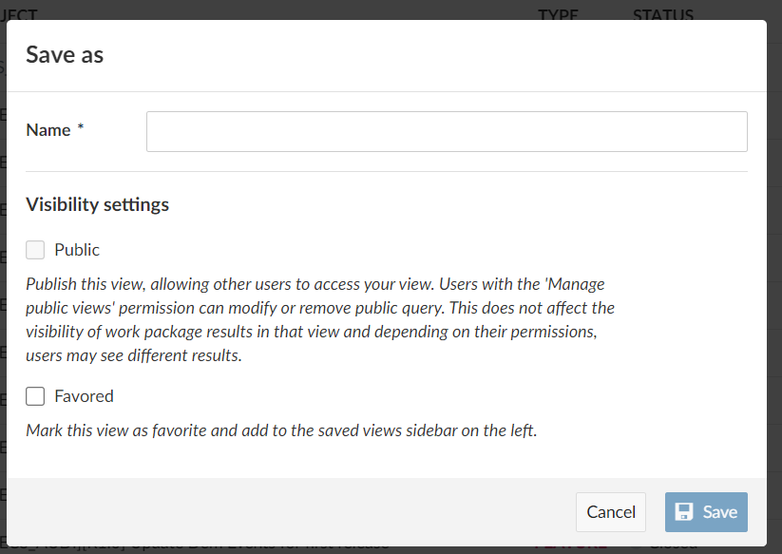

Give it a new name and then access it on the left side of the page under the private category. From the page link copy the last six digits after the “id=”.



Enter the output excel so you can have all issues from OpenProject. First enter the information in the configuration window. You might need to only enter the id mentioned above only in the QueryID field. After that delete all contents except the headers from the excel, press ctrl+b and then download everything again.

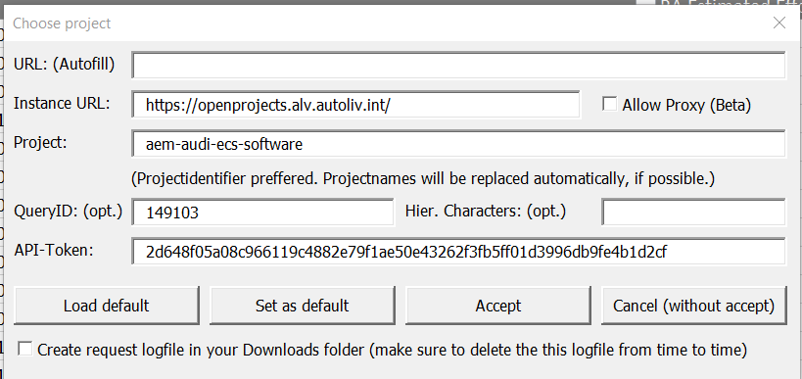

Before you run the script you can take the excel from outputs and copy it in the backup outputs folder, because there is the high change after running the script you won’t be able to upload the information. After running the script, enter in the outputs folder and copy the contents from the excel to the backup one. Don’t copy the file to the backup folder (you can copy the headers as well, but they should be the same in both folders). If everything was copied in the backup folder, press ctrl+b and upload the data to OpenProject (it is also recommended after pressing ctrl+b to also check the configuration of the project).